********************************************************************************
Excersise 1
Aim: Generate Prime and Fibonacci numbers within the range given by user as input.
Reg No. 24251115
Date 17-05-2025
********************************************************************************
start = int(input("Enter a starting number: "))
end = int(input("Enter an ending number: "))

def prime(start, end):
primeNumbers = []
for i in range(start, end + 1):
if i > 1:
for j in range(2, i):
if i % j == 0:
break
else:
primeNumbers.append(i)
return primeNumbers

def fibonacci(n):
fibNumbers = []
a, b = 0, 1
while a <= n:
fibNumbers.append(a)
a, b = b, a + b
return fibNumbers

primeNumbers = prime(start, end)
fibNumbers = fibonacci(end)
print("Prime numbers between", start, "and", end, "are:", primeNumbers)
print("Fibonacci numbers up to", end, "are:", fibNumbers)

Output:
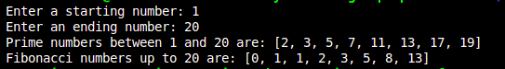

********************************************************************************
Excersise 2
Aim: Create a tuple with different data types and print each element. Check if an element exists in a tuple.
Reg No. 24251115
Date 17-05-2025
********************************************************************************
tup = (1, 2.5, "Hello")
print("Tuple:", tup)

search = 2.5
if search in tup:
print(f"{search} exists in the tuple.")
else:
print(f"{search} does not exist in the tuple.")

Output:
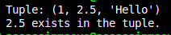

********************************************************************************
Excersise 3
Aim: Create an empty list. Input ‘n’ items. Count total number of Odd, Even, and zero items in the list and display the contents of new lists.
Reg No. 24251115
Date 17-05-2025
********************************************************************************
number = int(input("Enter the number of items in the list: "))
numbers = []

for i in range(number):
item = int(input(f"Enter the items in the list ({i + 1}/{number}): "))
numbers.append(item)
print("List:", numbers)

even = []
odd = []
zero = []

for i in numbers:
if i == 0:
zero.append(i)
elif i % 2 == 0:
even.append(i)
else:
odd.append(i)

print("Even numbers:", even)
print("Odd numbers:", odd)
print("Zero numbers:", zero)
print("Total even numbers:", len(even))
print("Total odd numbers:", len(odd))
print("Total zero numbers:", len(zero))

Output:
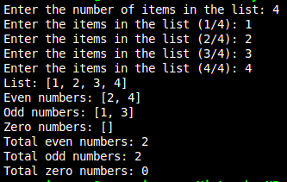

********************************************************************************
Excersise 4
Aim: Create a List n Integers and perform linear search on the list to find a number which is user input.
Reg No. 24251115
Date 17-05-2025
********************************************************************************

lst = [1,2,3,4,5,6,7,8,9]
search = int(input("Enter the number to search: "))

for i in range(len(lst)):
if lst[i] == search:
print(f"{search} found at index {i}")
break

Output:
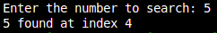

********************************************************************************
Excersise 5
Aim: Write a function that returns the second-largest element in a tuple of integers.
Add, remove, and insert elements in the list.
Reg No. 24251115
Date 17-05-2025
********************************************************************************
def secondLargest(tup):
largest = second = float('-inf')
for i in tup:
if i > largest:
second = largest
largest = i
elif i > second and i != largest:
second = largest
return second

tup = (1, 2, 3, 4, 5, 6, 7, 8, 9)
print(secondLargest(tup))

Output:
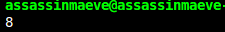

********************************************************************************
Excersise 6
Aim: Write a Python function that takes a list of integers as parameter and function should return the maximum and minimum numbers from the list. (don’t use built-in methods)
Reg No. 24251115
Date 17-05-2025
********************************************************************************
def findMaxMin(lst):
max = min = lst[0]
for i in lst:
if i > max:
max = i
if i < min:
min = i
return max, min

lst = [1, 2, 3, 4, 5, 6, 7, 8, 9]
print("List:", lst)
print(f"Maximum: {findMaxMin(lst)[0]} Minimum: {findMaxMin(lst)[1]}")

Output:
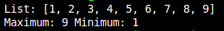

********************************************************************************
Excersise 7
Aim: Write a menu driven program to convert Input string into Upper case, Lower Case, Proper case, or swap case.
Reg No. 24251115
Date 17-05-2025
********************************************************************************
def menu():
print("----Menu----")
print("1. Convert to Upper Case")
print("2. Convert to Lower Case")
print("3. Convert to Proper Case")
print("4. Convert to Swap Case")
print("5. Exit")

def convert():
menu()
while True:
choice = int(input("Enter your choice: "))
if choice == 1:
string = input("Enter a string: ")
print("Upper Case:", string.upper())
elif choice == 2:
string = input("Enter a string: ")
print("Lower Case:", string.lower())
elif choice == 3:
string = input("Enter a string: ")
print("Proper Case:", string.title())
elif choice == 4:
string = input("Enter a string: ")
print("Swap Case:", string.swapcase())
elif choice == 5:
print("Exiting...")
break
else:
print("Invalid choice. Please try again.")

obj = convert()

Output:
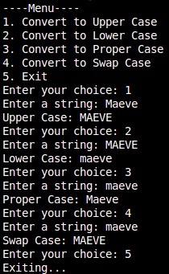

********************************************************************************
Excersise 8
Aim: Create two sets containing ‘n’ elements, using menu driven approach Perform all the basic operations on both the sets
Reg No. 24251115
Date 17-05-2025
********************************************************************************
def inputSet():
set1 = set()
set2 = set()
n = int(input("Enter the number of elements in the set: "))
for i in range(n):
element = int(input(f"Enter element {i + 1}: "))
set1.add(element)

n = int(input("Enter the number of elements in the second set: "))
for i in range(n):
element = int(input(f"Enter element {i + 1}: "))
set2.add(element)
return set1, set2

def menu():
print("----Menu----")
print("1. Union")
print("2. Intersection")
print("3. Difference")
print("4. Symmetric Difference")
print("5. Subset")
print("6. Superset")
print("7. Exit")

def setOperations(set1, set2):
menu()
while True:
choice = int(input("Enter your choice: "))
if choice == 1:
print("Union:", set1.union(set2))
elif choice == 2:
print("Intersection:", set1.intersection(set2))
elif choice == 3:
print("Difference:", set1.difference(set2))
elif choice == 4:
print("Symmetric Difference:", set1.symmetric_difference(set2))
elif choice == 5:
print("Subset:", set1.issubset(set2))
elif choice == 6:
print("Superset:", set1.issuperset(set2))
elif choice == 7:
print("Exiting...")
break
else:
print("Invalid choice. Please try again.")

set1, set2 = inputSet()
setOperations(set1, set2)

Output:
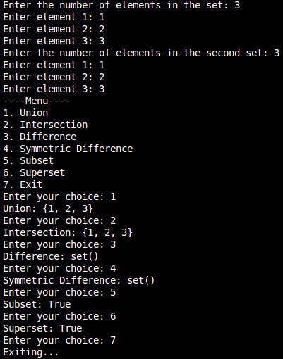

********************************************************************************
Excersise 9
Aim: Write Python program to Accept string and count the total number of vowels, consonants and blanks in a String. (Use Assert statement to accept strings only)
Reg No. 24251115
Date 17-05-2025
********************************************************************************
s = input("Enter a string: ")
assert isinstance(s, str), "Input must be a string"

vowels = 0
consonants = 0
blanks = 0

for char in s:
if char.lower() in 'aeiou':
vowels += 1
elif char == ' ':
blanks += 1
elif char.isalpha():
consonants += 1

print("Vowels:", vowels)
print("Consonants:", consonants)
print("Blanks:", blanks)

Output:
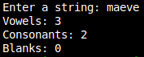

********************************************************************************
Excersise 10
Aim: Create a dictionary with few key-value pairs. Access and modify dictionary values.
Reg No. 24251115
Date 17-05-2025
********************************************************************************
student = {
"name": "Alice",
"age": 20,
"course": "Python"
}

# Accessing values
print("Name:", student["name"])
print("Age:", student["age"])
print("Course:", student["course"])

# Modifying values
student["age"] = 21
student["course"] = "Data Science"

print("\nAfter modification:")
print("Name:", student["name"])
print("Age:", student["age"])
print("Course:", student["course"])

Output:
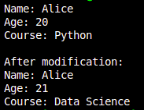

********************************************************************************
Excersise 11
Aim: Create a Dictionary containing Key value pairs, Keys are ‘Eno’, Ename, ‘’City’, ‘Designation’ and Salary. Write a menu driven program to use dictionary methods Insert, Update, Delete and Get Methods
Reg No. 24251115
Date 17-05-2025
********************************************************************************

********************************************************************************
Excersise 12
Aim: Find the mean, median, and standard deviation of an array.
Reg No. 24251115
Date 17-05-2025
********************************************************************************

